do-while Script
Script to run for a number of times
- #!/bin/bash
- c=1
- while [ $c -le 5 ]
- do
- echo "Welcone $c times"
- (( c++ ))
- Done
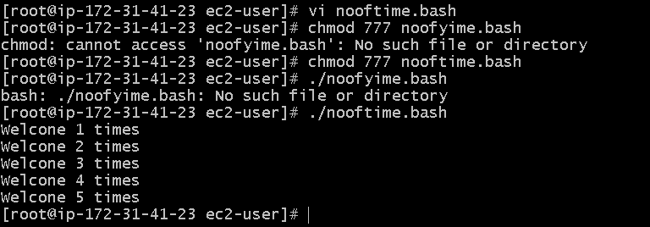

Script to run for a number of seconds
- #!/bin/bash
- count=0
- num=10
- while [ $count -lt 10 ]
- do
- echo
- echo $num seconds left to stop this process $1
- echo
- sleep 1
- num=`expr $num - 1`
count=`expr $count + 1`
done
echo
echo $1 process is stopped!!!
Echo

